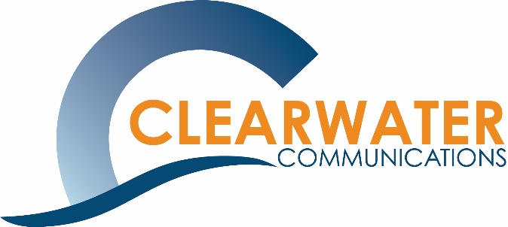
FOR IMMEDIATE RELEASE
June 30, 2026

Contact:
Shannon Schutt, President
Clearwater Communications
701-355-4458
sschutt@clearwatercommunications.net
www.clearwatercommunications.net

Clearwater Communications Announces Michaela Randall’s Promotion
BISMARCK – Clearwater Communications is pleased to announce the promotion of Michaela Randall to client communications and events lead.
In her new role, Randall will continue to lead client communications initiatives while overseeing event planning and website management services for many of the organization's association clients. She will play a key role in supporting client engagement, event success and communication strategies.
Since joining Clearwater in April 2023, Randall has demonstrated exceptional growth, dedication and a strong commitment to serving both clients and colleagues. Through her work in event planning, website management and client support, she has developed expertise that has become an important asset to the organization.
“Michaela has shown tremendous growth and a strong commitment to both our team and our clients,” said Shannon Schutt, president of Clearwater Communications. “We are excited to see her continue to develop in this new role and know she will continue to make a meaningful impact for our clients.”
Randall's promotion reflects Clearwater Communication's commitment to investing in employee development and recognizing team members who demonstrate leadership, initiative and excellence in client service.
“We believe in creating opportunities for our team members to grow into their strengths,” Schutt said. “Michaela's promotion is a wonderful example of that commitment in action.”
About Clearwater Communications
Clearwater Communications provides association management services, including executive leadership, communications, event planning, membership management, financial services, and strategic support to nonprofit and professional organizations throughout North Dakota.
###

